**Managing Reports and Fields in Odoo**

**1. Deactivating a Report**

To deactivate a report in Odoo, set the active field to False in the XML record:

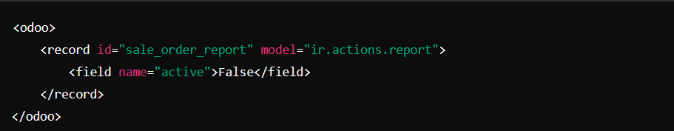

**2. Unlinking a Report from the Model**

To unlink a report from a model, set the binding_model_id to False:

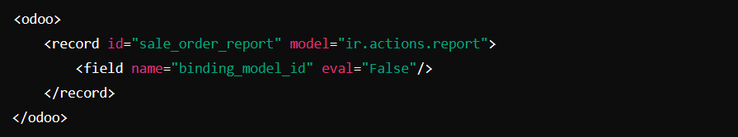

Alternatively, you can remove the report action using Python code:

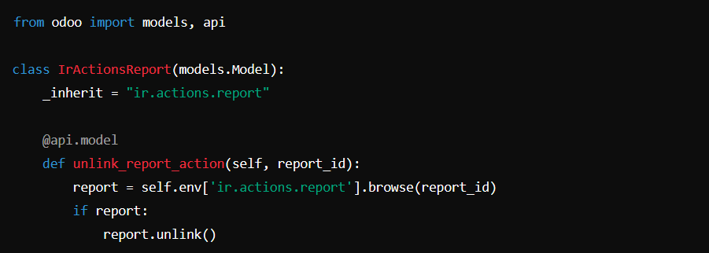

**3. Removing Elements Using XPath**

**Removing a Field from a Form View**

To remove the "phone" field from a form view:



**Removing a Specific Print Button**

To remove a specific print button from the interface:



**Hiding the Print Menu Action**

To locate and remove the Print menu action:

